**SWE-6733 Team-3 Sprint 3 Submission**

**Testing Documentation**

**Introduction**

The purpose of this document is to outline and demonstrate the implementation of testing in our project. In the following sections, testing formats and frameworks used, project-specific test implementations, and the process executing tests have been described. In addition, a demonstration of test suite output has been included at the end of the document.

**Unit Testing**

We have used unit testing to test individual functional components of our project, helping to ensure that things work as intended. In addition, these unit tests help us to better identify issues which arise after changes are made. To perform this testing, we have utilized the *jest* JavaScript unit testing framework, as well as several packages to support testing in the *React* environment, and a jest configuration has been written to integrate these packages and support *@babel*.

A complete list of packages utilized in the project can be found in the *package.json* file, and the jest configuration is contained within the *jest.config.json* file. The complete path to each of these files is shown here:

./TogetherDating/AdventureTogether/package.json

./TogetherDating/AdventureTogether/jest.config.json

The current set of unit tests can be found in the /src/tests/ directory of /AdventureTogether.

**Behavior Driven Development (BDD) Testing**

In addition to jest, we have implemented the *jest-cucumber* package, which runs on top of jest and allows for the integration of BDD testing. This approach to testing allows for feature-focused tests to be performed, specifically in the context of acceptance criteria, using the ‘*Given, When, Then’* format.

BDD tests are implemented in the /src/features/ directory of /AdventureTogether. Each test is comprised of two files: one which establishes a scenario in standard English, and another which links a set of behavioral tests to this scenario. A test passes when the scenario completes with the expected outcome. Our project currently contains one complete test, however with this framework implemented, we will move to implement additional acceptance tests in the following sprints.

**Execution of Tests**

Tests are configured to be executed via the command line using the *Yarn* utility for *node.js*. The project has been configured to execute all tests via the command *‘yarn test’*. A report detailing the results of the testing suite is automatically generated by this process each time the tests are run.

**Test Demonstration (Sprint 1)**

Below is a screen capture of the sprint 1 test set being run against the submission repository:

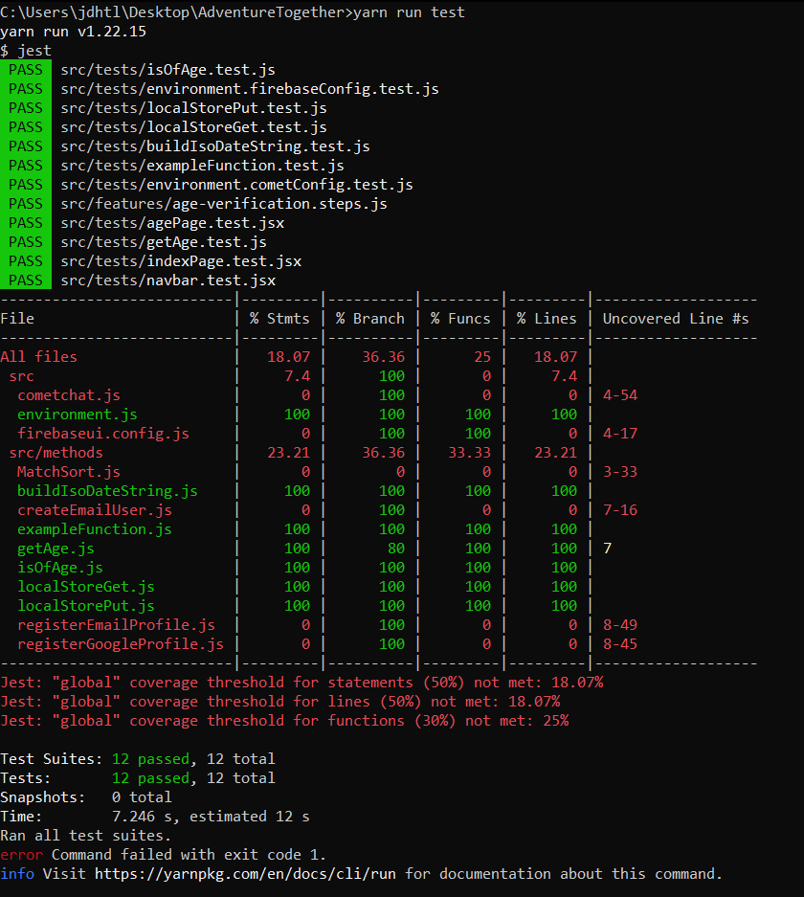

Each of the incorporated unit tests as well as the BDD test passes. We have not yet configured the coverage aspect of the testing framework such that it produces useful output, but aim do to so in the next sprints if feasible.

**Test Demonstration (Sprint 2)**

Below is a screen capture of the current test set being run against the submission repository:

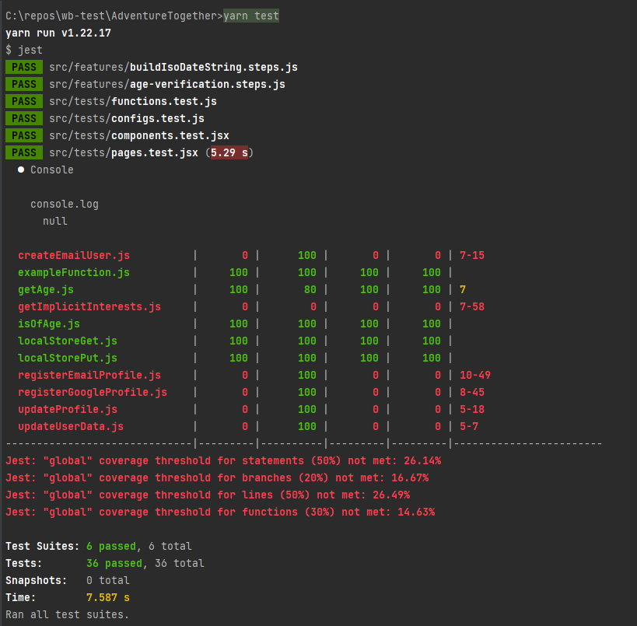

The unit tests have been restructured into a set of suites, to better manage the increasing size of the collection. These unit testing suites each address a different aspect of the application. In considering testing in this way, we have been able to identify a more complete set of test surfaces for our application.

The degree of coverage attained is significantly impeded by the close coupling of the current high-level component set with the Google Firebase and Firestore APIs, and their associated component modules. Due to security-related limitations, traditional unit testing frameworks are not compatible with elements of our application which are composed from these components.

**Testing Demonstration (Sprint 3)**

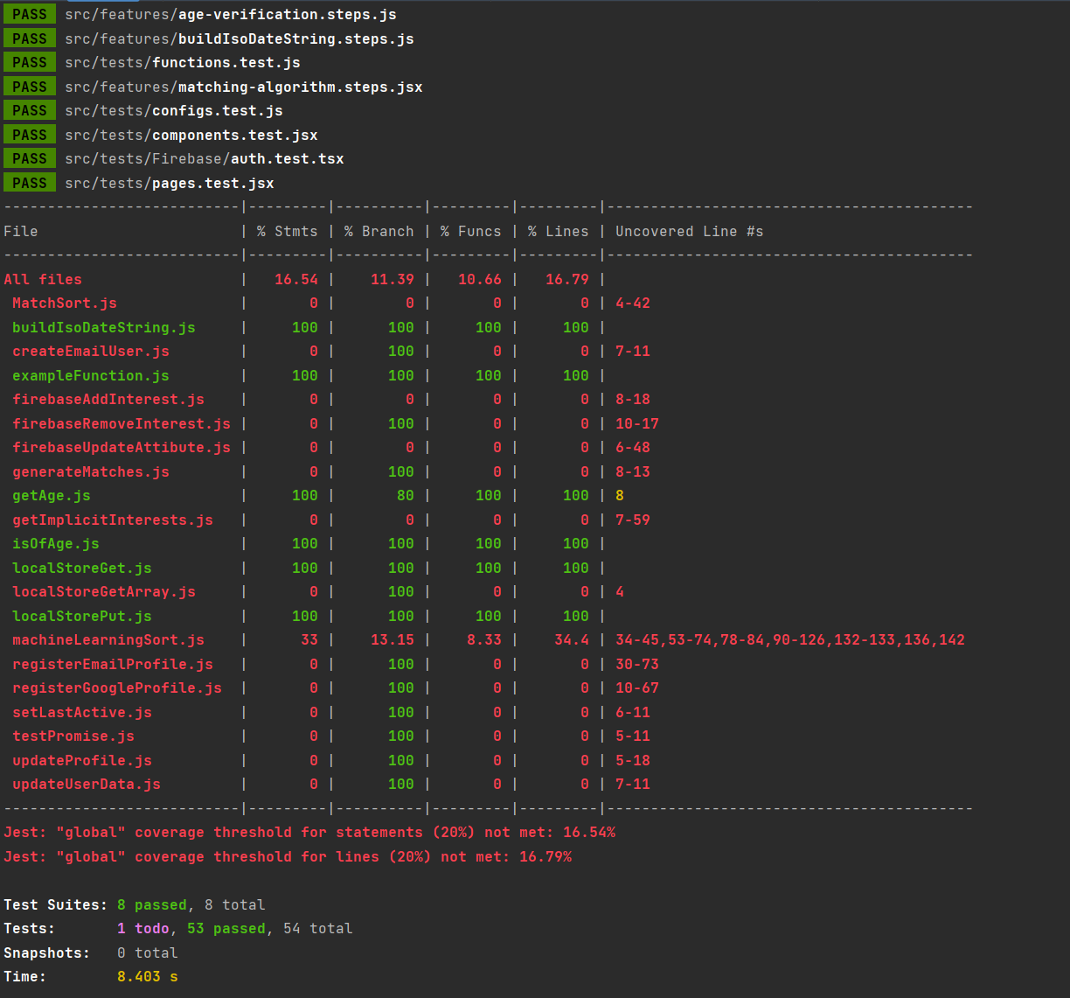

In sprint 3, we faced some difficulties in testing our project as the coupling of our components with Google Firebase suite has increased by a significant factor. To overcome this hurdle in part, more complex tests have been designed in order to set up the necessary firebase providers. In addition, focus was shifted toward testing individual components as opposed to individual page, as it is more practical to maintain operational tests across changes in this context. A third BDD test has also been incorporated in the broader test suite collection which verifies that the matching algorithm is returning data.

In addition, we have made extensive use of the *reactfire* node library. This utilizes the v9 iteration of Firebase service applications, which we have discovered carries an expensive price with regard to testing. While Firebase v9 applications can be initialized with ease, there is no public method accessible to terminate these initializations. In the context of our application, this simply means that reactfire is terminated by the garbage collection process. However in the context of jest, this means that the teardown process cannot successfully handle closing the initialized listeners, which causes the test suite to hang. Nevertheless, we have built additional unit tests to test components utilizing this library. An execution which includes these additional tests is shown below, **producing a total run of 60 tests.**

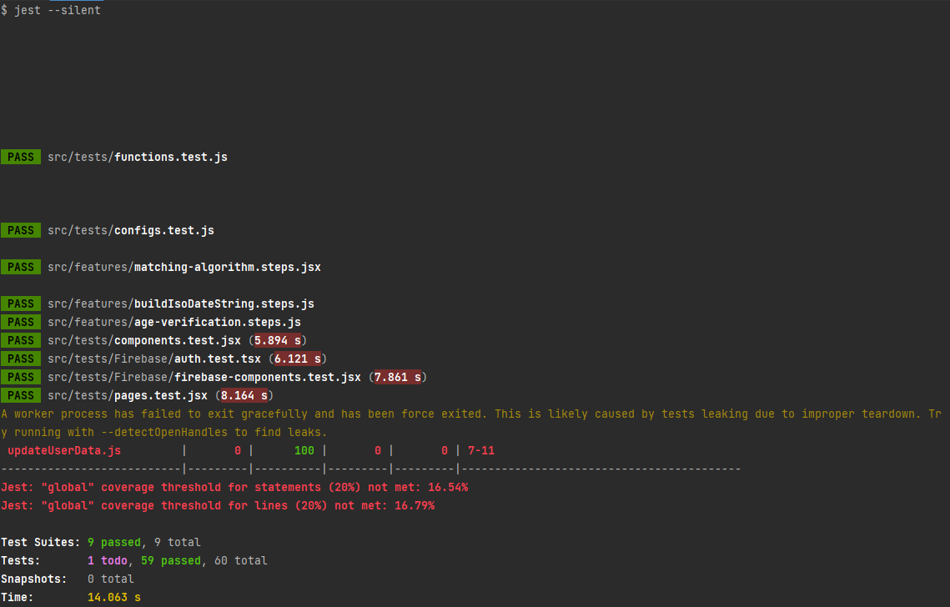

During this sprint, we have also configured the Firebase emulator node package, which assists in testing functionality which would otherwise interact with the live Firebase API. The use of this emulator is necessary due to certain protocols used by Firebase which make it somewhat incompatible with jest. The configuration and execution script for this emulator has been included in our submission at the top level of directories. An image of this emulator running during our testing can be found below. In order to allow our test suite to be automatically executed upon deployment, tests which rely on this emulation are executed through a separate command, *yarn test-all*.

*Firebase Emulator in use during full testing.*

**Testing Software and Related References**

jest <https://jestjs.io/>

jest-cucumber <https://github.com/bencompton/jest-cucumber>

React <https://reactjs.org/>

babel <https://babeljs.io/>

JavaScript <https://developer.mozilla.org/en-US/docs/Web/JavaScript>

Node.js <https://nodejs.org/en/>

Yarn <https://yarnpkg.com/>